1. **Create a virtual environment.**
   1. Open a command line terminal on a windows computer with python installed.
   2. Use the command python -m venv *fpath* to create a new virtual environment, where *fpath* is the full path for the destination of the virtual environment.



* 1. Activate the virtual environment with the command *fpath*\Scripts\activate.bat The name of the virtual environment will be prepended to your terminal prompt if successful.



* 1. Use pip to install desired packages. (<https://packaging.python.org/tutorials/installing-packages/>). The typical syntax is pip install *package*

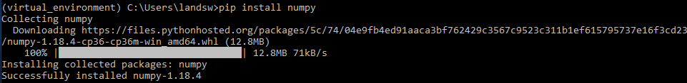

* 1. Launch python in the console and import installed packages to ensure installation success.

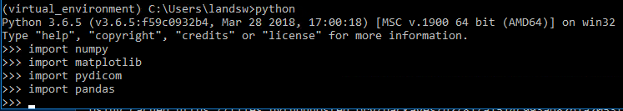

1. **Install virtual environment (for all users – please consult/coordinate with IT).**
   1. Open clinic settings (requires correct permissions).  
        
      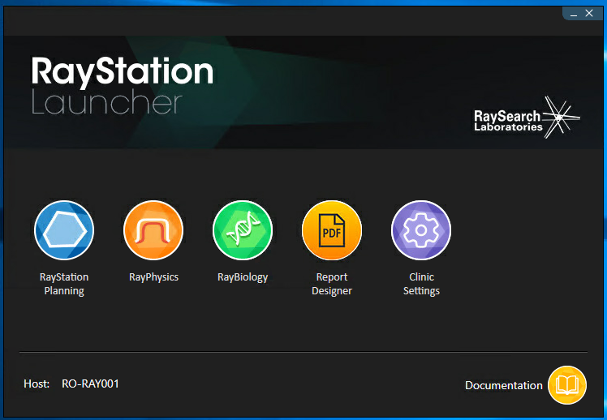

* 1. On the scripting tab, click ‘Add Environment’. Name the environment and click ‘Browse…’

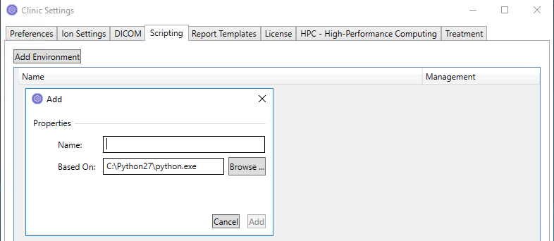

* 1. Navigate to *fpath*\Scripts and select python.exe. Click ‘Add’ to create the environment.

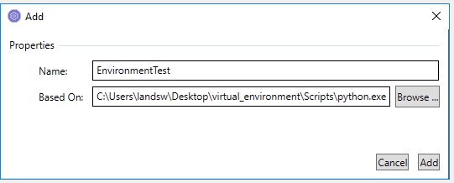

* 1. If desired, edit environment by clicking the ‘Edit’ button. Additional third party modules can be installed here using the pip command. This can also be used to confirm installed modules were transferred to the Raystation environment successfully using pip list. It seems some modules are consistently transferred (e.g. numpy) and others are not (e.g. matplotlib).

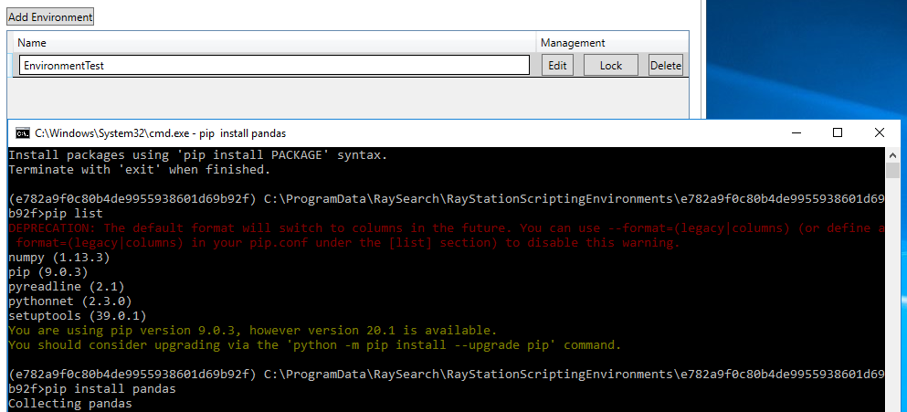

* 1. Select this environment in the dropdown when creating a new script to have access to the installed modules.

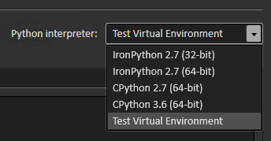

1. **Activate virtual environment (for one user, for development).**
   1. Run the console launching script.
   2. Create a new console window by clicking ‘File’ -> ‘New Tab’ -> ‘Console2’

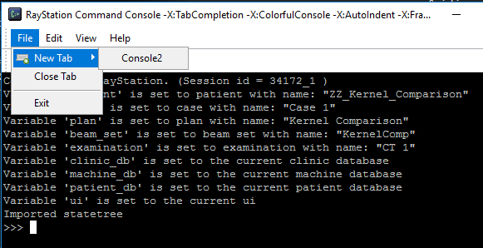

* 1. Activate the virtual environment with the command *fpath*\Scripts\activate.bat

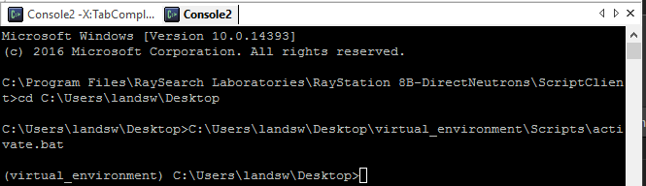

* 1. Navigate to the Raystation script client directory using cd C:\Program Files\Raysearch Laboratories*RaystationVersion*\ScriptClient

*RaystationVersion* should be replaced with the actual filepath (e.g. Raystation 8B)



* 1. Run python using the command python. Import the connect module to gain access to patient/image/plan attributes, and import statetree to access the statetree.

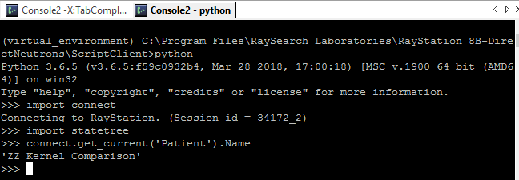

1. **Connect to Raystation from Spyder (**[**https://docs.spyder-ide.org/ipythonconsole.html**](https://docs.spyder-ide.org/ipythonconsole.html)**).**
   1. Install spyder-kernels in the virtual environment that will be used if it is not already installed. pip install spyder-kernels
   2. Run the command python -m spyder_kernels.console

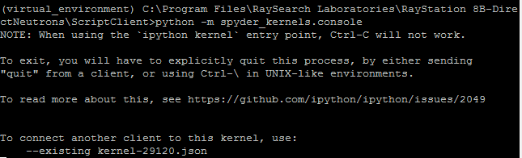

* 1. A kernel will be created on the local machine at C:\Users*username*\AppData\Roaming\jupyter\runtime. Connect to it in Spyder by clicking the gear icon at the top left of the Spyder console, and clicking ‘Connect to an existing kernel’. Browse to the json file created in the Raystation console.

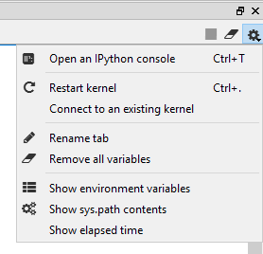

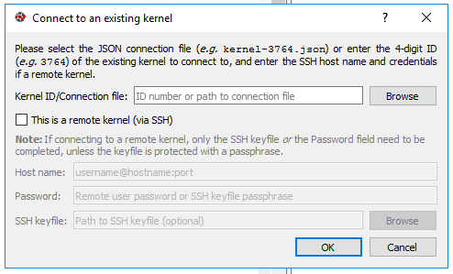

1. **Troubleshooting: Wrong ‘clr’ module installed…**
   1. When running Raystation code in an activated environment, if you encounter the following Exception (AttributeE
   2. In the activated virtual environment, run pip uninstall clr
   3. After successful uninstall, run pip install pythonnet